**Lab_Day-7 ANP-C9180 (For Loop)**

* Print the first 10 natural numbers using for loop

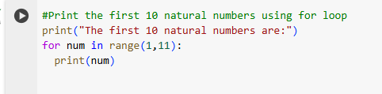

Output:

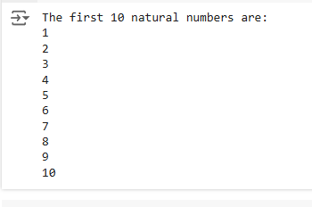

* Python program to check if the given string is a palindrome

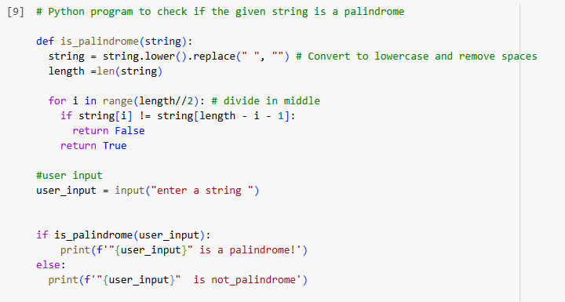

Output



* Python program to check if a given number is an Armstrong number

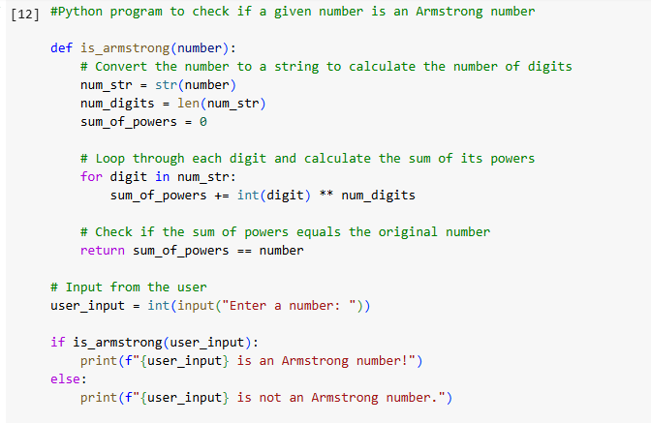

Output

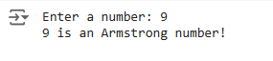

* Python program to get the Fibonacci series between 0 to 50

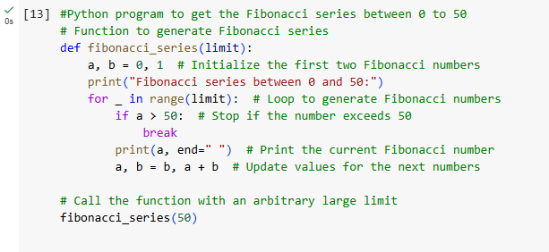

Output

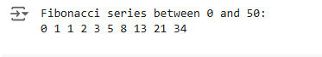

* Python program to check the validity of password input by users

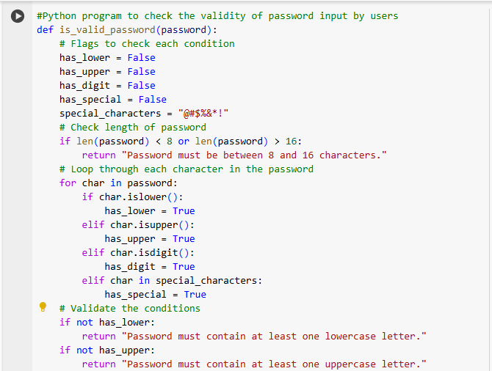

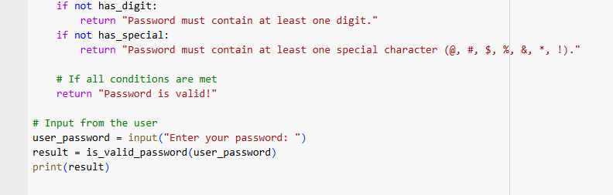

Output

